Polyfunctional Argument Markers in Ket: Implicative Structure within the Word
Keywords: Ket, polyfunctionality, implicative structure, syntagmatics

Ket is the last of the indigenous Yeniseian languages of central Siberia. Ket indexes both subjects and direct objects on the verb, but the way in which this is done varies significantly from one lexeme to another, forming a fairly complex system of inflectional classes (Nefedov & Vajda 2015). There is substantial reuse of material across different classes, such that the same marker may be the sole marker of the subject (1), or a co-exponent of the subject with another marker (2), or an object marker (3), depending on the verb. Furthermore, several argument markers represent a fusion or reanalysis of historically distinct markers, and alternatively or simultaneously encode completely orthogonal functions, (marking tense, cf. 4 and 5), or serve no obvious function.
This situation, wherein same marker systematically encodes different functions across different lexemes, is known as Polyfunctionality (Stump 2015). It represents a type of complexity of exponence (Anderson, 2015), a phenomenon wherein there is a non-isomorphic or otherwise opaque relationship between units of meaning (e.g. tense, person) and the formal units which are used encode them (e.g. affixes, stem alternations). Polyfunctionality of the type seen in Ket would seem to present a communicative challenge in decoding; If the same marker can encode many different functions across different lexemes within the same subsystem of the morphology, on an arbitrary basis, how does a Ket listener understand which of the possible functions is intended in the given instance? This problem is made more acute by the fact that the language is pro-drop and exclusively head marking with regard to core syntactic arguments (Kotorova & Nefedov 2016).
The potential communicative challenges presented by complex form~meaning mappings has been a major focus of much recent work in morphological complexity (Ackerman et al. 2009, Ackerman & Malouf 2015, Sims & Parker 2016). Such work has largely focused on the question of how speakers of morphologically complex languages predict forms which they have never directly encountered (the so-called Paradigm Cell Filling Problem). If a language can encode the same information in many different ways (via affix allomorphy, stem changes etc.), how does a speaker know how to encode the information in any given form, provided that they have never encountered that form before? As a solution, such work implicates the property of inflectional paradigms known as implicative structure (Wurzel 1984). The morphology of a language exhibits implicative structure if known forms of a lexeme provide clues to unknown forms, such that all cells in a paradigm can be predicted from some subset of these cells. By hypothesis, form~meaning mappings in a language may be complex, provided that the necessary form can be predicted in any given instance (the Low Conditional Entropy Conjecture).
However, this work has largely not focused on the role that implicative structure may play in decoding, as opposed to encoding, complex form~function mappings, nor on the role of implicative structure in syntagmatic, as opposed to paradigmatic, structure. Using data drawn from both published sources and original fieldwork, this paper demonstrates that in Ket, although individual argument markers are often highly polyfunctional, they are organized into networks of implicative relations which greatly reduce uncertainty with regard to their function in any particular instance. In other words, the range of possible functions for a particular argument marker can be greatly reduced by observing which other argument markers are present or absent in the same wordform, and which features those encode (cf. 6 and the dependency graph in 7). In this way, uncertainty with regard to the function of the wordform can be kept low, even without reference to the syntactic context or knowledge of paradigmatically related forms. As a case study, Ket is suggestive of a sort of “Low Conditional Entropy Conjecture in decoding”, wherein individual markers may be highly polyfunctional, provided that their functions can be determined in any given instance. The role of syntagmatic implicative structure in achieving this in Ket underscores the point made by Sims and Parker (2016) that the amount of work done by implicative structure is a point of cross-linguistic variation. It also makes predictions for other head-marking languages with very high complexity of exponence.
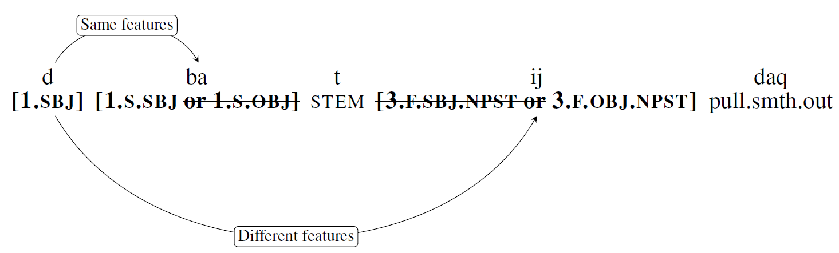
(1) ba (1.s) as sole exponent of subject  avəriŋbaɣara  avəriŋ-ba-ɣ-a-ra  spend.the.day-1.s.sbj-stem-n.pst-stem  ‘I spend the day’  [Kotorova & Nefedov, 2015; pg. 435] | (2) ba as co-exponent of subject with another marker  daɣabatsaq  d-aɣa-ba-t-s-aq  1.sbj-make.a.trip.to.forest.and.return-1.s.sbj-stem-pres-stem  ‘I will make a quick trip to the forest and return’  [Kotorova & Nefedov, 2015; 438]
(3) ba as object marker  kejbaɣava  k-ej-ba-ɣ-a-v-a  2.s.sbj-throw-1.s.obj-stem-n.pst-stem-stem  ‘you throw me’  [Vajda & Zinn, 2004; 139] | (4) o marks past tense and 3m  usʲondæn  usʲ-o-n-dæn  fall.asleep-3.s.m.sbj.pst-pst-stem  ‘he fell asleep’  [Valentina Romanenkova, speaker p.c.]
(5) o markers only past tense (subject marked by ba)  avəriŋbaɣolda  avəriŋ-ba-ɣ-o-l-da  spend.the.day-1.s.sbj-stem-pst-pst-stem  ‘I spent the day’  [Kotorova & Nefedov, 2015; 435] | (6)  dbatijdaq  d=ba-t-ij-daq  1.sbj=[1.s.sbj or 1.s.obj]-stem-[3.f.sbj or 3.f.obj]-pull.out  ‘I pull her out’  [Valentina Romanenkova, speaker p.c]
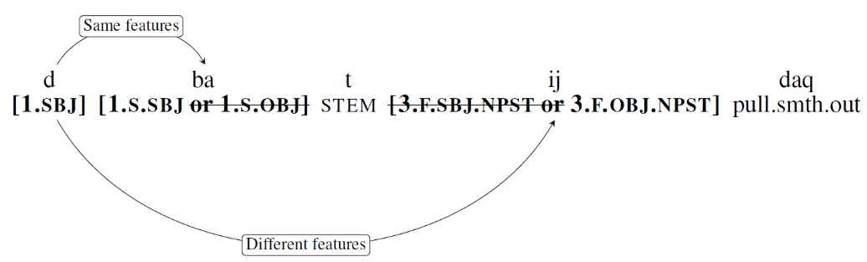
(7)

Selected References
Ackerman, Farrell, James Blevins, and Rob Malouf. (2009). Parts and Wholes: Patterns of Relatedness in Complex Morphological Systems and why they Matter. Analogy in Grammar: Form and Acquisition, 54:82
Ackerman, Farrell and Rob Malouf. (2015). The No Blur Principle Effects as an Emergent Property of Language Systems. In Proceedings of the annual meeting of the Berkeley Linguistics Society, Volume 41
Kotorova, Elizaveta and Andrey Nefedov, A. (2015). Comprehensive Dictionary of Ket. München: Lincom Europa.
Kotorova, Elizaveta and Andrey Nefedov. (2006). Tipologicheskie xarakteristiki ketskogo jazyka: vershinnoe ili zavisimostnoe markirovanie? Voprosy Jazykoznanija, (5):43–56.
Nefedov, Andrey and Edward Vajda. (2015). Grammatical Sketch of Ket. Comprehensive Dictionary of Ket, pp. 27–68.
Sims, Andrea, & Jeff Parker. (2016). How inflection class systems work: On the informativity of implicative structure. Word Structure, 9(2), 215-239.
Stump, Gregory. (2015). Inflectional paradigms: Content and form at the syntax-morphology interface, volume 149. Cambridge University Press.
Vajda, Edward and Marina Zinn. (2004). Morfologicheskij slovar’ ketskogo glagola, na osnove juzhno-ketskogo dialekta. Tomsk: Tomsk Pedagogical University.

